**EX:No.4 LINEAR REGRESSION 221501040 21/01/25**

**AIM :** To implement linear regression on a time series data .

**ALGORITHM :**

Step 1: Load the sales data from a CSV file and set 'Order Date' as the index.

Step 2: Calculate daily percentage returns from the Sales column and remove missing or infinite values.

Step 3: Create a new column called Lagged_Return by shifting the return values by one day, then drop any resulting NaNs.

Step 4: Split the cleaned data into training and testing sets using an 80/20 ratio.

Step 5: Train a Linear Regression model using the Lagged_Return to predict the actual Return.

Step 6: Predict on the test set and plot the first 20 actual vs predicted return values for comparison.

**IMPLEMENTATION :**

import numpy as np

import pandas as pd

from pathlib import Path

import matplotlib.pyplot as plt

from sklearn.linear_model import LinearRegression

# Enable inline plots (for Jupyter or Colab)

%matplotlib inline

# Load your dataset

sales_df = pd.read_csv(

Path("cleaned_sales_data.csv"), index_col="Order Date", parse_dates=True

)

# Calculate percentage returns for 'Sales'

sales_df['Return'] = sales_df['Sales'].pct_change() * 100

# Replace inf/-inf with NaN and drop all NaNs

returns = sales_df.replace([np.inf, -np.inf], np.nan).dropna()

# Create lagged return

returns['Lagged_Return'] = returns["Return"].shift()

returns = returns.dropna()

# Print latest date in data to verify

print("Latest date in dataset:", returns.index.max())

# Split into train/test using 80/20 index-based split

split_idx = int(len(returns) * 0.8)

train = returns.iloc[:split_idx]

test = returns.iloc[split_idx:]

# Create X and y sets

x_train = train[["Lagged_Return"]]

y_train = train["Return"]

x_test = test[["Lagged_Return"]]

y_test = test["Return"]

# Fit Linear Regression Model

model = LinearRegression()

model.fit(x_train, y_train)

# Make predictions

predictions = model.predict(x_test)

# Assemble results

results = y_test.to_frame()

results["Predicted Return"] = predictions

# Plot the first 20 predictions vs actual returns

results[:20].plot(subplots=True, figsize=(10, 6), title=["Actual Return", "Predicted Return"])

plt.tight_layout()

plt.show()

**OUTPUT:**

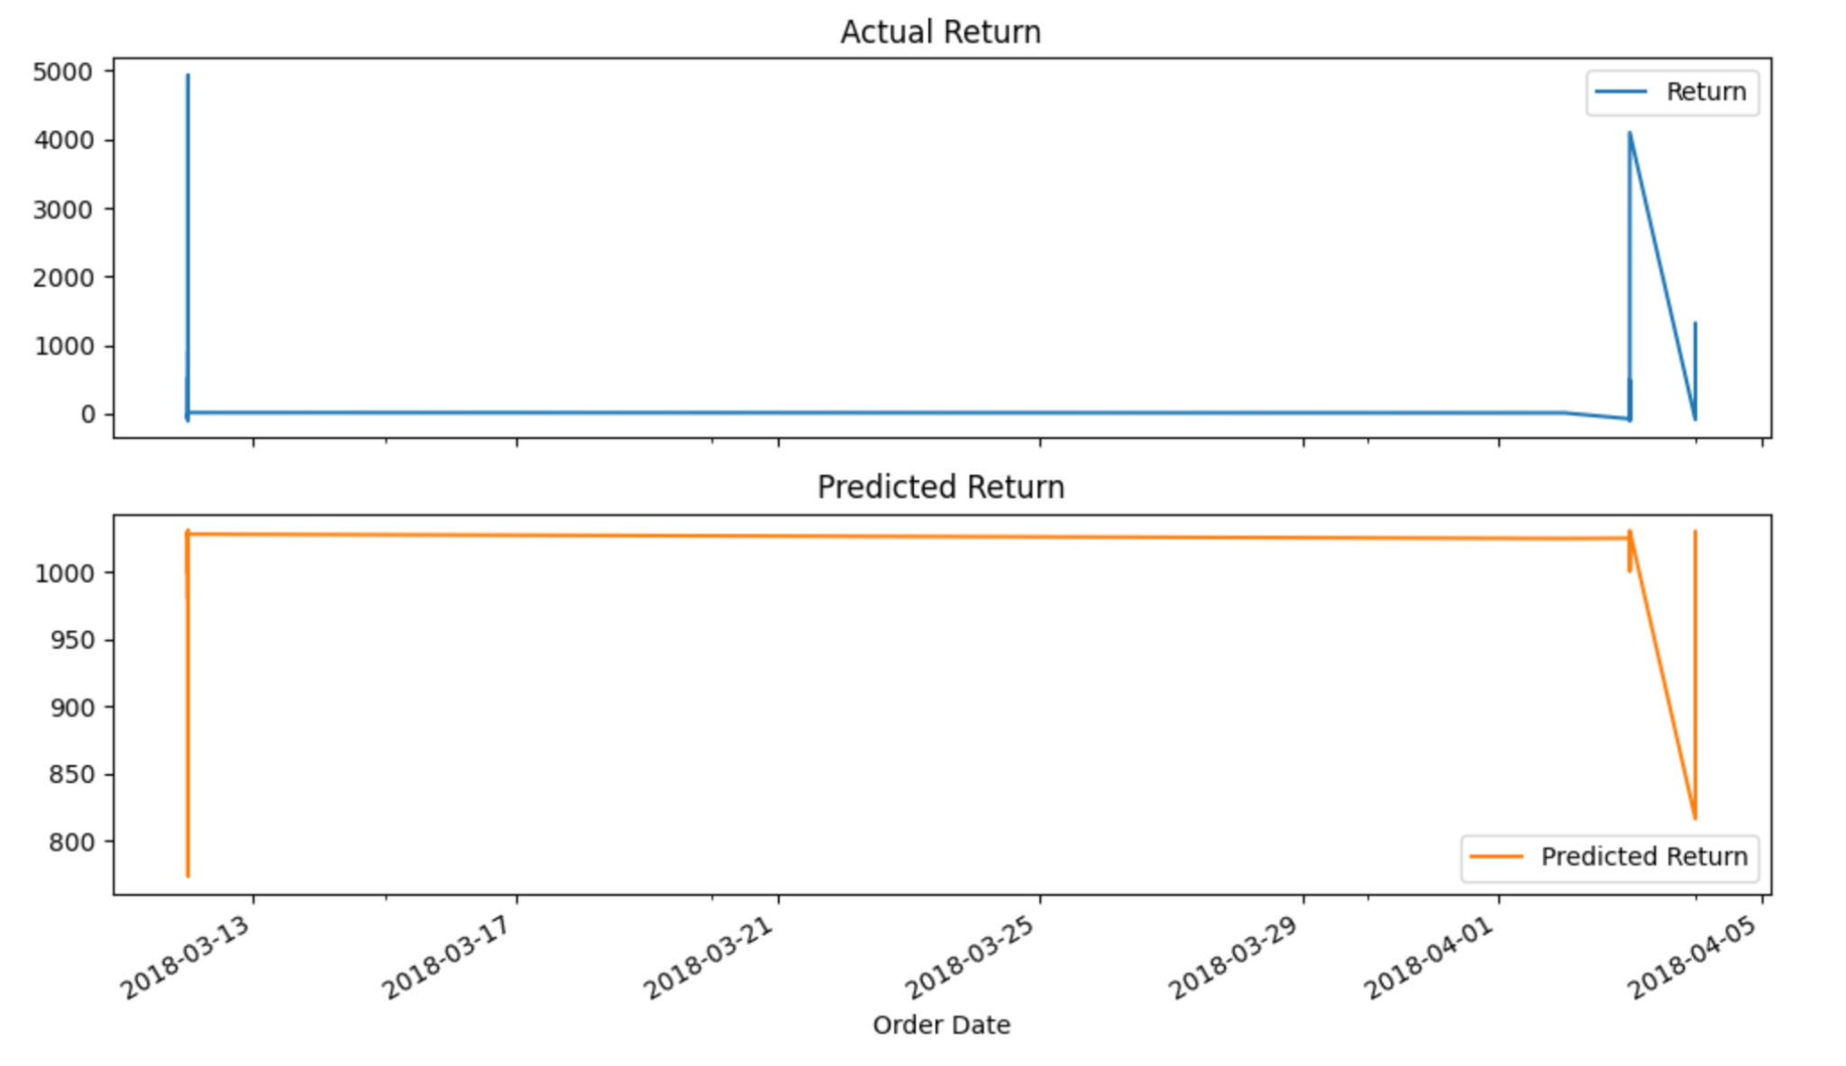

**RESULT :** Thus linear regression has been implemented on a time series data.